**Artifact Repository**

* There are two popular options for java
  + jfrog/artifactory
  + Nexus
* Azure DevOps has Azure Artifacts
* In this series we will be using jfrog/artifactory for its multi-language repository support.
* <https://jfrog.com/start-free/> for 14 day free trail  
  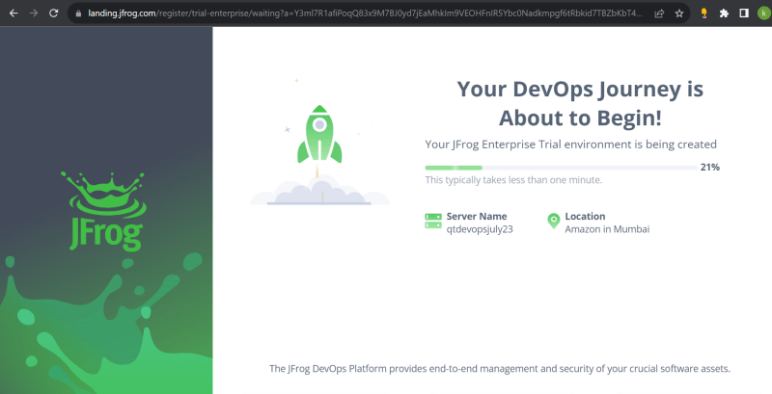
* For configuring jenkins with artifactory <https://directdevops.blog/2019/10/17/artifactory-configuration/>